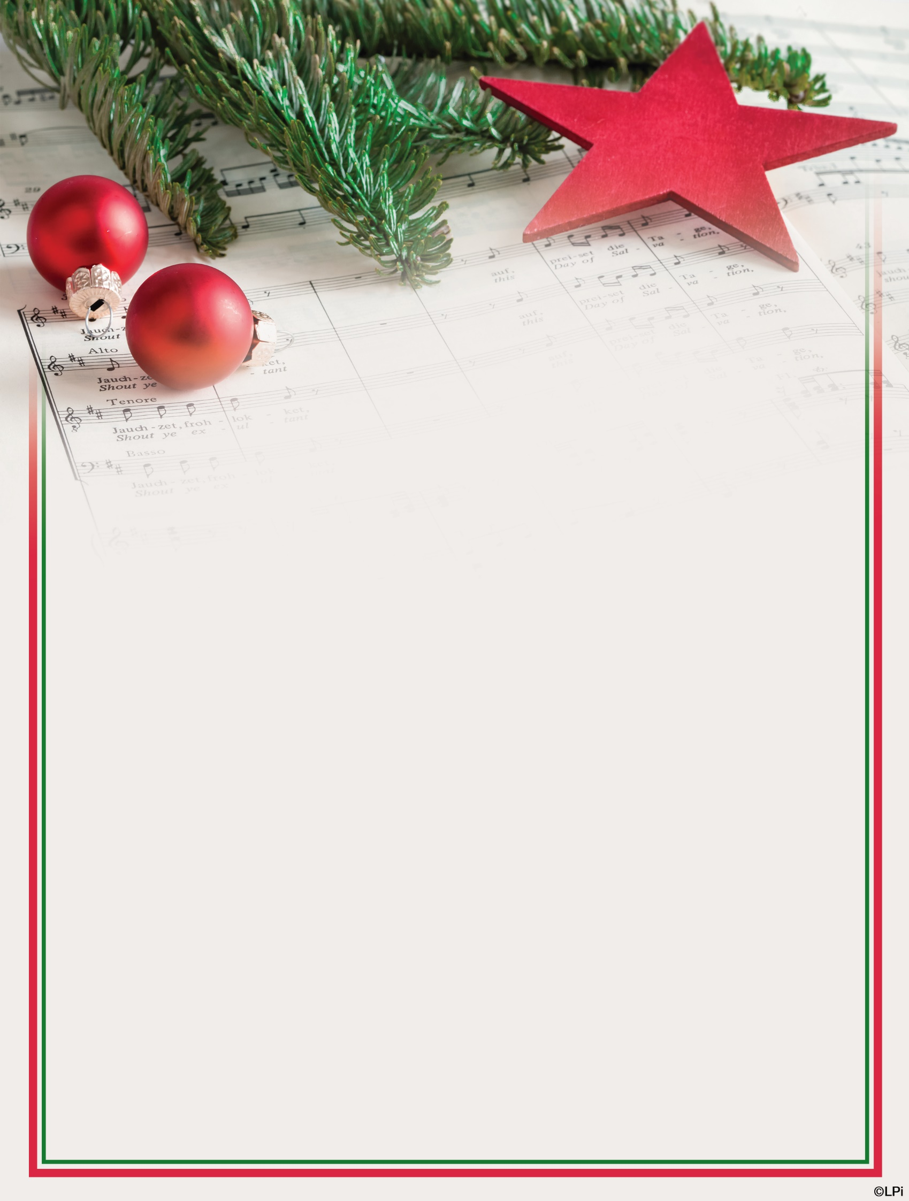

Youth and Parents - Of All Ages (and Skill Levels!)
Children’s Christmas Choir
Please join us in the choir loft at the 6:30 Mass on Christmas Eve for an evening of singing and celebration of the Nativity!
Schedule - please attend as many as you can so we are able to sing as a unified group!
- Thursday, November 30th, 5:30-6:30 in the loft
- Thursday, December 7th, 5:30-6:30 in the loft
- Friday, December 15th, 5:30-6:30 in the loft
- Sunday, December 24th, 5:30 warm up in the loft, 6:00 caroling, 6:30 Mass
If you or your children are interested in participating in this musical ministry, please reach out to Paul Rosenberger, the Director of Music and Liturgy, at rosen.p@stalbg.org. Thank you for considering helping with this important part of our liturgy!

